**GRAPHICS DESIGN USING CANVA**

1. **INTRODUCTION**
   1. Overview
   2. Purpose

* Thoughtful course design keeps the focus on the outcomes (knowledge, skills, and habits of mind) you consider most important for student success. Good course design saves time, improves the equity of course experience for students, and deepens learning for all.

1. **PROBLEM DEFINTION**
   1. Empathy Map

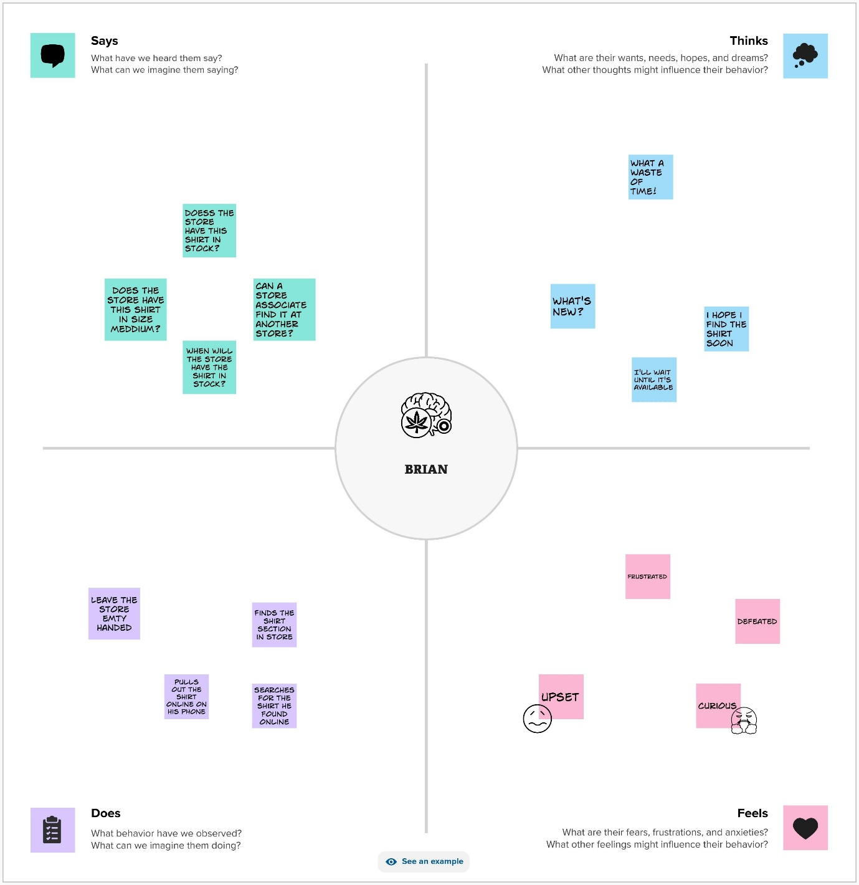

.

* 1. Brainstorming Map

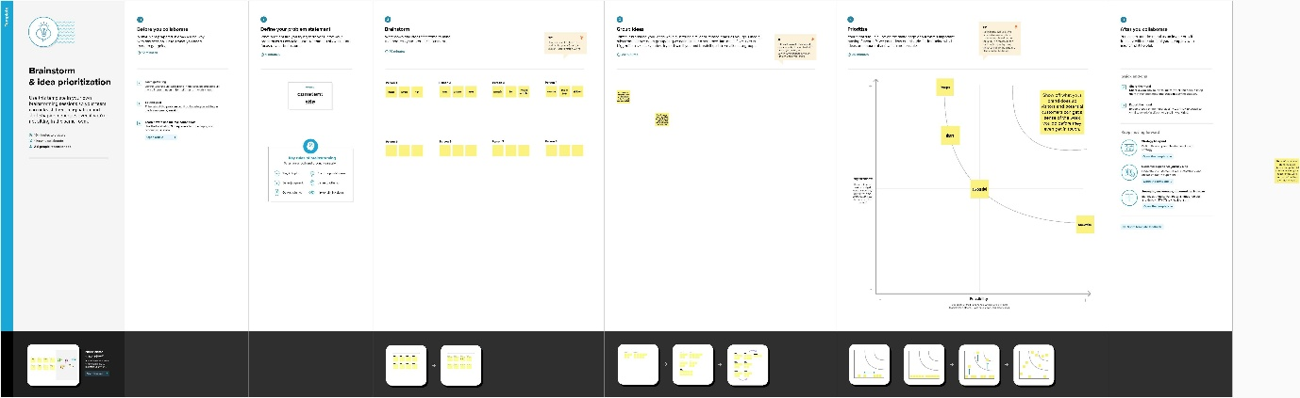

1. **RESULT**

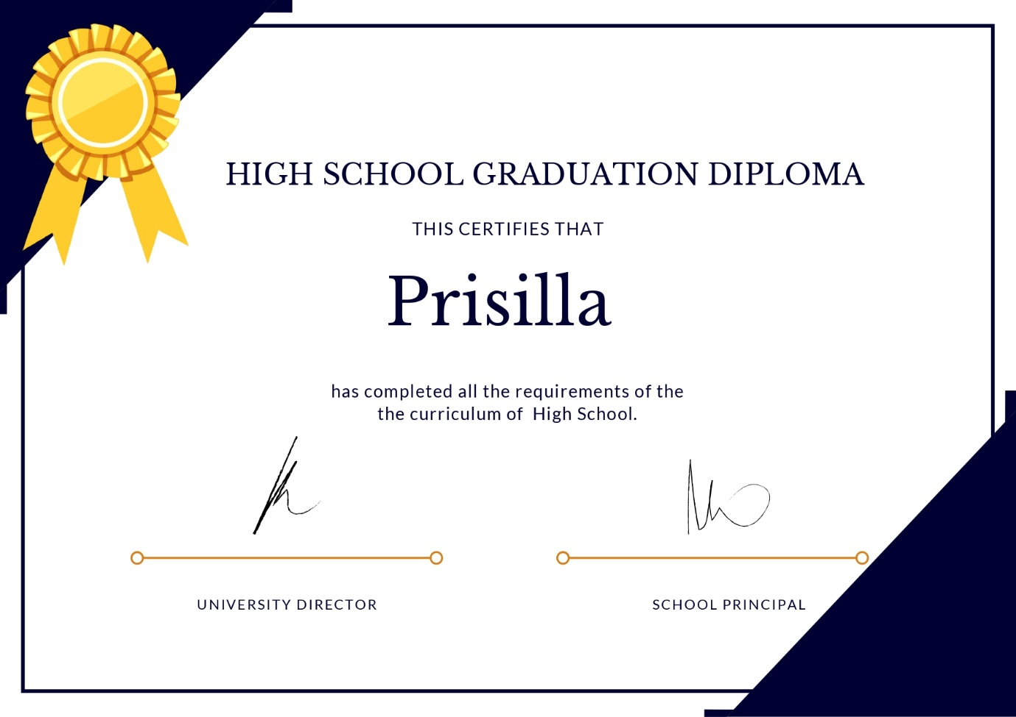

1. **ADVANTAGES & DISADVANTAGES**

Advantages

* 1. Develop creativity

Fashion design courses offer an opportunity to develop creativity and express oneself through design. Students must experiment with different fabrics, textures, colours, and styles to create unique designs. This creativity is essential for success in the fashion industry, where innovation and originality are highly valued.

2. Learn technical skills

Fashion design courses provide students with technical skills like pattern drafting, sewing, and garment construction. These skills are crucial for designing and producing high-quality garments. Students learn to work with different fabrics and materials and create custom designs that fit clients’ needs.

3. Gain industry knowledge

Fashion design courses provide students with industry knowledge such as fashiohistory, trend forecasting, and marketing. This knowledge is essential for success in the fashion industry, as it allows designers to understand the market and make informed design decisions.

4. Develop business skills

Fashion design courses teach students how to manage a fashion business, including finance, marketing, and sales. These skills are essential for running a successful fashion business and should be noticed more by designers who focus solely on design.

5. Networking opportunities

Fashion design courses provide networking opportunities for students to connect with industry professionals. This networking can lead to internships, job opportunities, and collaborations. These connections are invaluable in the fashion industry, where networking is essential for success. Good fashion designing colleges will help students to do better

Common Understanding and same mindset of whole team members

* Disadvantag
* .Limited Liquidity: The owner of a Certificate cannot access their money as easily as a traditional savings account. To withdrawal money from a Certificate before the end of the term requires that a penalty has to be paid. ...
* High stress level. Stress level for a design engineer is usually high as compared to the average stress level for different jobs. There are always deadlines and pressure of completing the job as per requirement. Project work can call for long hours to meet deadlines.
* The main risk with a certificate of deposit is that you may need to pay the penalty if you withdraw your money before the end of the term. This can eat into your earnings, so it’s important to ensure you won’t need the money during that time. Another risk to consider is that rates may change for your term.
* Inflation Risk: Certificate rates may be lower than the rate of inflation

1. **APPLICATIONS**

**Certificate design is an important aspect of any training program or event, as it serves as a tangible reminder of the accomplishment and recognition of the participants’ efforts.**

1. **Conclusion**

Getting certified can increase your knowledge of a subject, qualify you for new opportunities and improve your earning potential. Earning a certificate in graphic design is often a useful way to show employers you care about your professional development and possess the skills they’re looking for in a job candidate.